TRIWING ENDOR – crew profile

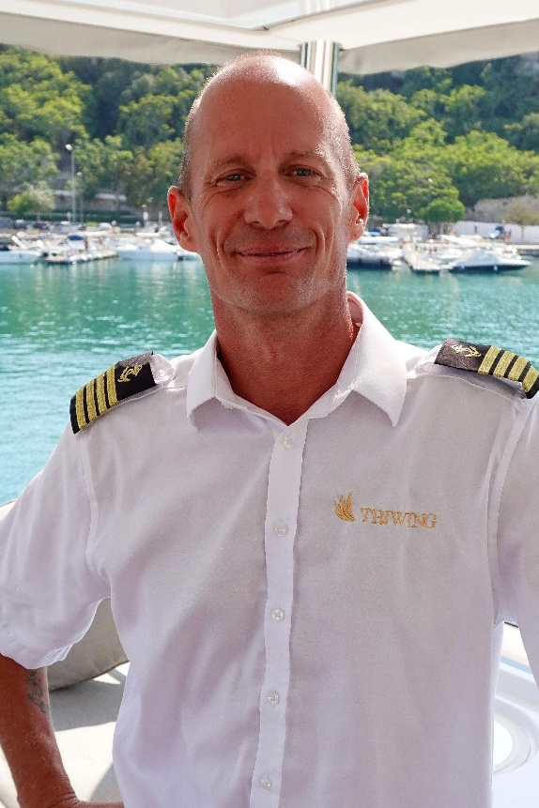
---Captain Philip Bienz---
Swiss-born and Yachtmaster Ocean-qualified, Philip brings a wealth of maritime experience, from transatlantic deliveries to luxury charter operations in Europe and the Caribbean. With MCA Master 200 Unlimited certification and fluency in five languages, he combines precise navigation skills with a warm, guest-focused approach. Passionate about sailing, surfing, fishing and the Ocean, Philip ensures every voyage is safe, seamless, and unforgettable.
Qualifications:
STCW 2010 Basic Safety Training
MCA Master 200 Unlimited
Yachtmaster Ocean Power
Yachtmaster Ocean Sail
Commercial Endorsement
ENG1
ICC Power and Sail
MCA AEC 1 Approved Engine Course
Chieftan 12V Marine Electrics
PADI Open Water Diver
Languages: English, German, Spanish, Portuguese, French

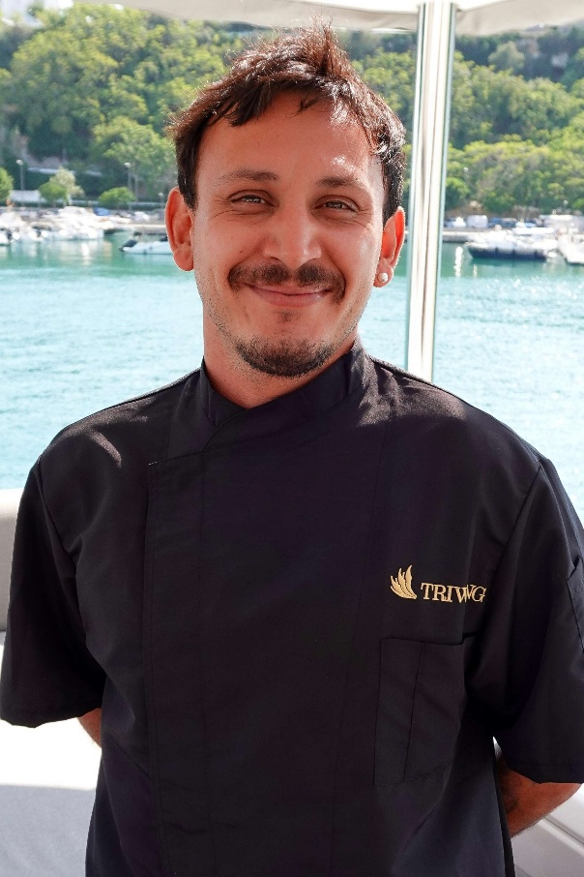
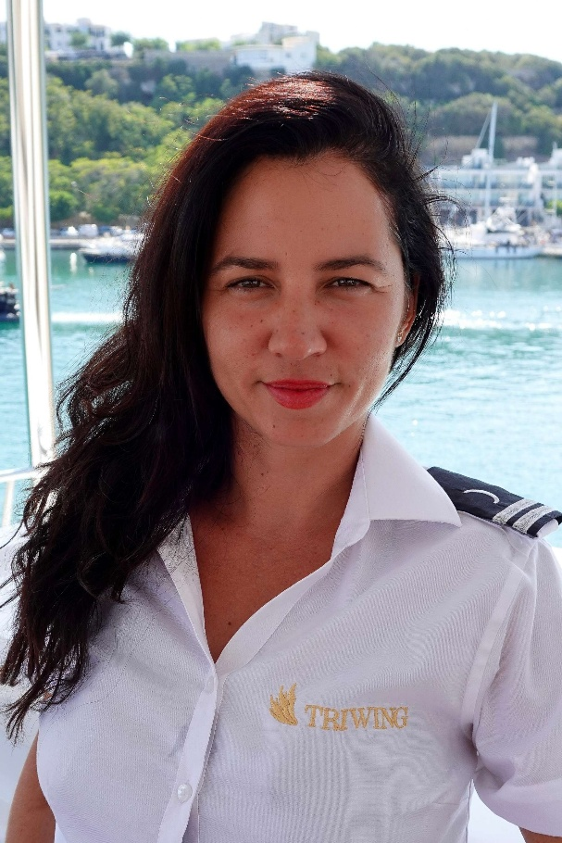
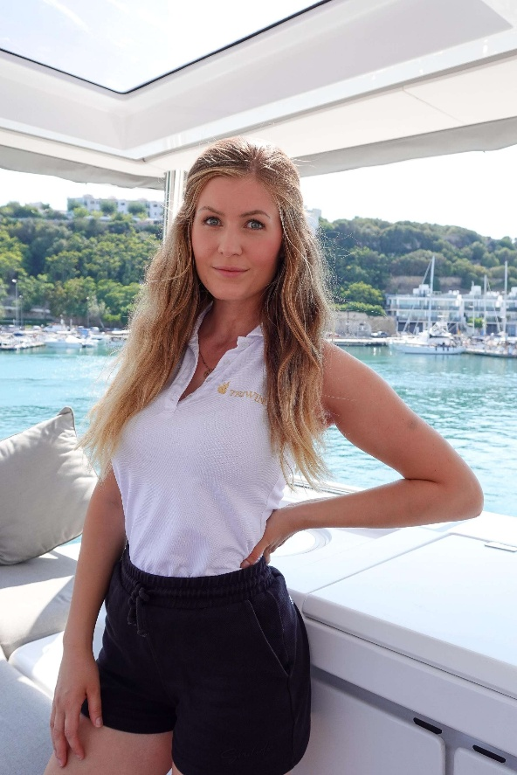
---Chef Matias Pellegrini---
Hailing from Argentina, Matias is a talented chef with an international culinary background, blending Mediterranean, Latin American, and contemporary flavors. With years of experience in high-end kitchens and aboard luxury yachts, he creates beautifully presented, flavor-rich dishes tailored to guests’ tastes. Matias’s creativity, passion for fresh ingredients, and attention to detail make every meal an experience to remember.
Qualifications:
STCW 2010 Basic Safety Training
Advanced Diploma in Gastronomy (Higher Technician in Culinary Arts), University of Islas Malvinas
Languages: English, Spanish
---Hostess & Masseuse - Hanna Möller---
Hanna is a professional and versatile yacht stewardess with a passion for guest service, wellness, and creating a welcoming atmosphere on board. Trained in massage therapy, yoga instruction, and hospitality, she ensures guests feel relaxed and cared for throughout their stay. With her positive energy, attention to detail, and multilingual skills, Hanna makes every charter feel personal and special.
Qualifications:
STCW 2010 Basic Safety Training
First Aid Certification
Yoga Instructor Certification
Master Wellness Masseur Certification
Languages: English, German
---Deck & Watersports – Yuliet Montes---
With a background as a private chef and extensive hospitality experience, Yuliet brings both energy and versatility to her role on deck. She assists with water sports activities, keeps the yacht in pristine condition, and ensures guests have fun and feel at ease on and off the water. Friendly, adaptable, and passionate about the sea, Yuliet is always ready to make guests’ experiences exceptional.
Qualifications:
STCW 2010 Basic Safety Training
Motorboat License
Sailboat License
Jetski License
Padi Open Water Diver
SSI Advanced and Nitrox Diver
Ayurvedan Massage Therapist
Food Handler Course
Allergen and Food Intolerance Control Course
Kitchen Assistant Course – Hospitality School El Madroño Madrid
Languages: English, Spanish

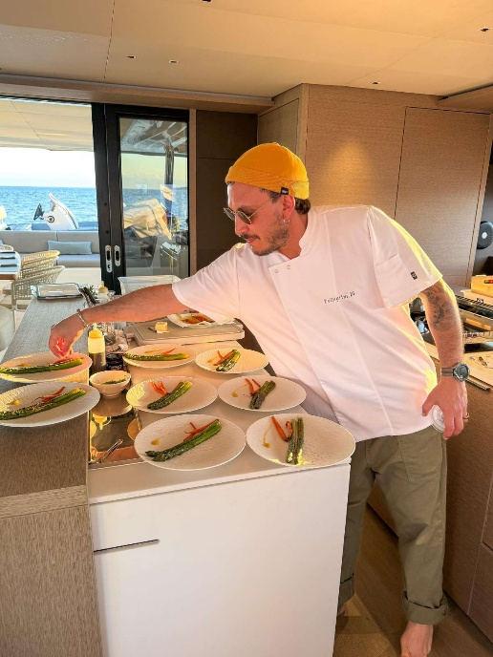
SAMPLE MENU
Sample Menu – Chef Matias Pellegrini
Blending the essence of Mediterranean and Latin American gastronomy, using fresh, seasonal products at their peak.
A refined culinary voyage aboard Lagoon 65 – Tri Wing Endor

Breakfast – Start the day with elegance and energy
Classic Eggs Benedict with Smoked Salmon & Hollandaise Sauce
Mediterranean Omelette with Feta, Spinach, Sun-Dried Tomatoes & Fresh Herbs
Shakshuka – Poached Eggs in Spiced Tomato & Pepper Sauce, served with Warm Pita Bread
Soft Scrambled Eggs with Truffle Oil & Chives on Sourdough Toast
Fresh Tropical Fruit Platter with Organic Yogurt & Honey
Warm Viennoiserie Selection – Croissants, Pain au Chocolat & Danish Pastries
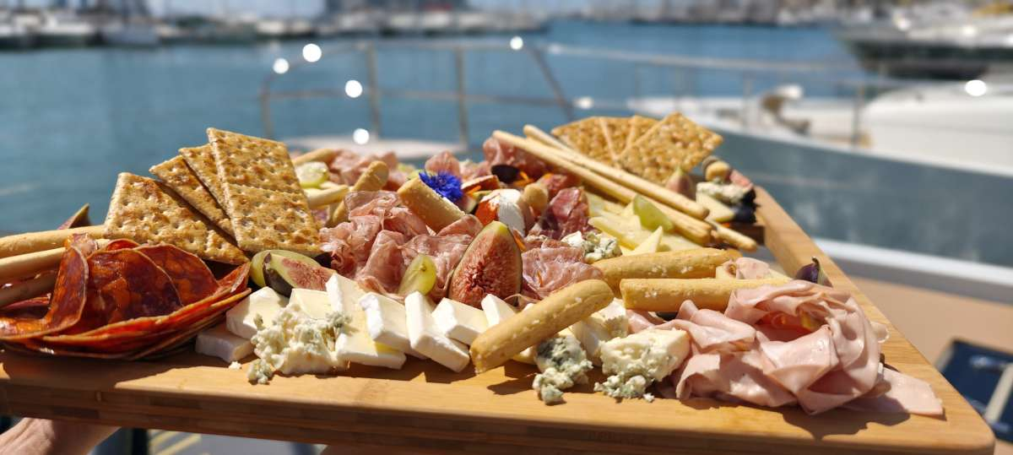

Lunch – Light yet indulgent, perfect for sunny afternoons at sea
Seared Scallops over Cauliflower Cream with Aromatic Green Oil
Mini Vietnamese Spring Rolls with Avocado, Mango & Lime-Soy Dipping Sauce
Crispy Panko-Breaded Prawns with Ripe Mango Mayonnaise
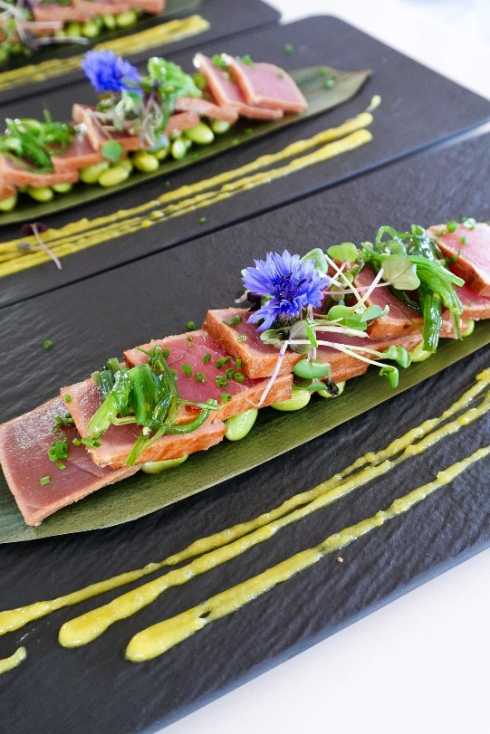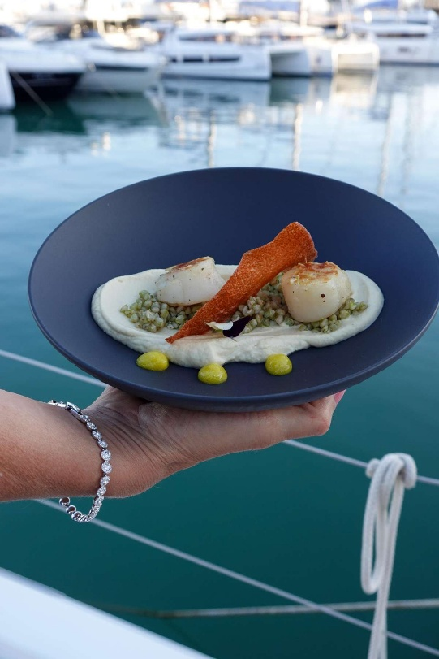
Creamy Vegan Risotto with Wild Mushrooms & Green Asparagus
Seasonal Garden Salad with Edible Flowers, Citrus Segments & a Champagne Vinaigrette
Fresh Catch of the Day Ceviche with Lime, Coriander & Red Onion
Lobster Salad with Citrus Vinaigrette & Baby Greens

Starters – An introduction to the evening’s symphony of flavors
Beetroot Tartare with Green Apple & Caramelized Walnuts
Seasonal Roasted Eggplants with Corn Cream, Criolla Sauce & Fresh Basil Leaves
Blinis with Avocado Cream & Confit Cherry Tomatoes
Salmon Tartare with Capers, Dill & Avocado
Seared Tataki Tuna with Sesame Crust & Ponzu Dressing
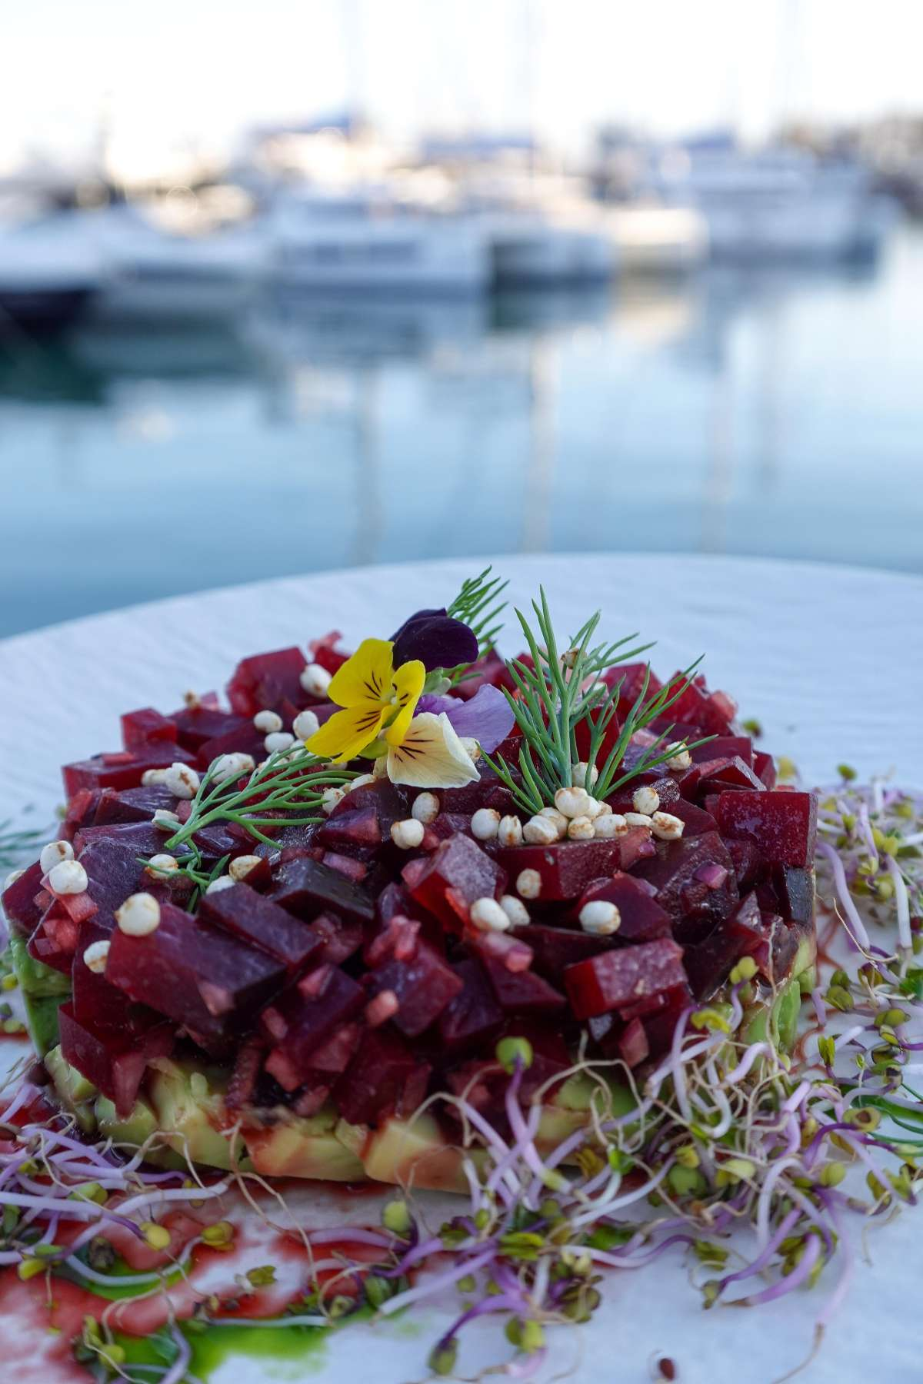
Dinner – The main act, a celebration of fine ingredients and skill
Roasted Meagre Fillet with Creamy Celeriac Purée, Green Asparagus & Bright Citrus Sauce
Braised Beef Cheeks in Their Jus with Rustic Mashed Potatoes & Glazed Baby Carrots
Grilled Lobster with Garlic Butter, Lemon & Herb Couscous
Vegan Red Berry Cheesecake with Almond Crust & Vanilla Infusion
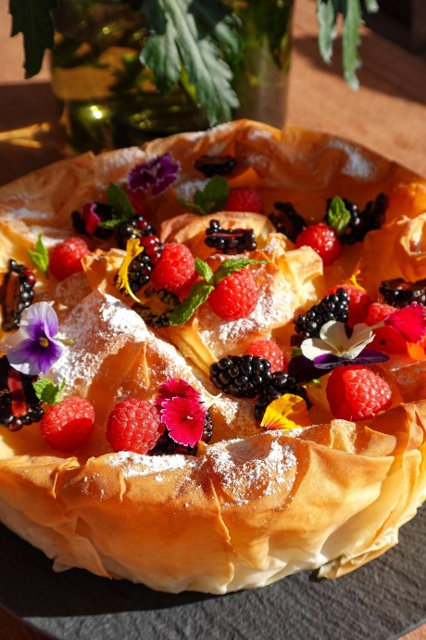
Desserts – The sweet finale to a perfect day
Chocolate & Avocado Mousse with Maldon Salt & Extra Virgin Olive Oil
Amaretto & Orange Tiramisu
Vegan Chocolate & Orange Truffles

